Academic Guidance and Motivation Intelligence System (AGMIS)
Title Page
Project Title: Academic Guidance and Motivation Intelligence System (AGMIS)
Domain: Data Science / Educational Analytics
Prepared By: Hamza Siddiqui
Institute: Atharva College, Malad
Degree: B.Sc. Data Science (Final Year Project)

Certificate
This is to certify that the project report entitled “Academic Guidance and Motivation Intelligence System (AGMIS)” submitted by Hamza Siddiqui in partial fulfillment of the requirements for the degree of B.Sc. in Data Science at Atharva College, Malad, is a bonafide record of original work carried out under my supervision and guidance.
The work embodied in this project has not been submitted to any other university or institution for the award of any degree or diploma.

Project Guide:
Name: ______________________
Signature: __________________
Head of Department:
Name: ______________________
Signature: __________________
External Examiner:
Name: ______________________
Signature: __________________
Date: ______________________
Place: Mumbai

Acknowledgment
I would like to express my sincere gratitude to [Guide Name], my project guide, for their continuous support, guidance, and valuable feedback throughout the development of this project.
I also thank the Head of Department and all faculty members of the Data Science Department, Atharva College for providing the academic environment and encouragement necessary to complete this work.
I am grateful to my classmates, friends, and family members for their constant motivation and constructive suggestions. Finally, I thank all individuals, directly or indirectly, who have contributed to the successful completion of AGMIS (Academic Guidance and Motivation Intelligence System).

Student:
Hamza Siddiqui

Abstract
Traditional academic evaluation in colleges is largely reactive: performance is judged at the end of the semester, after failures have already occurred. Students who were silently struggling are often identified too late, and faculty do not always get structured, data-driven signals about which students need early guidance.
The Academic Guidance and Motivation Intelligence System (AGMIS) is a data-driven academic analytics system designed to provide early academic guidance rather than late judgment. AGMIS analyzes institutional academic data such as attendance, internal marks, exam scores, and assignment submissions. It then classifies students into performance categories and generates explainable, transparent guidance that faculty and students can understand and defend.
The system consists of:
- A data processing and analytics backend that cleans, aggregates, and transforms academic data.
- A machine learning classification engine (Random Forest Classifier) that categorizes students into performance segments.
- A rule-based guidance engine that maps performance patterns to human-readable academic advice and motivational messages.
- A web-based dashboard that allows faculty to upload/update data and enables students to view their performance insights and guidance in a read-only, secure manner.
AGMIS is intentionally designed to avoid surveillance and opaque black-box predictions. It does not predict individual failure or long-term life outcomes. Instead, it focuses on explainable, batch-level and student-level academic guidance that can be defended during viva and accepted by faculty as academically sound and ethically safe.

Table of Contents
- Introduction
- Problem Definition
- Objectives and Scope
- System Analysis
- Software Requirements Specification (SRS)
- System Design
6.1 Overall Architecture
6.2 Use Case Diagram
6.3 Data Flow Diagrams (DFD)
6.4 Entity–Relationship (ER) Diagram
6.5 Sequence Diagram
- Algorithms and Models
- Implementation Details
- Testing and Validation
- Results and Discussion
- Limitations
- Future Enhancements
- Conclusion

1. Introduction
Academic performance in higher education is influenced by multiple factors: attendance, internal assessments, assignments, lab work, and final exam scores. Most institutions capture these as raw numbers, but rarely convert them into actionable intelligence for early intervention.
The Academic Guidance and Motivation Intelligence System (AGMIS) is a data science–driven system that transforms routine academic records into structured insights. It is designed for colleges that want to identify students who need support before they fail, and to provide transparent, data-backed guidance for both students and faculty.
AGMIS is not a flashy, black-box AI demo. It is a practical, explainable system with:
- Well-defined data pipelines,
- A justified machine learning model,
- Clear rules for guidance messages, and
- A dashboard suitable for real academic usage.
This report documents the complete lifecycle of AGMIS, including requirements, design, algorithms, implementation, and evaluation.

2. Problem Definition
2.1 Existing System
In many colleges, academic monitoring follows a post-mortem pattern:
- Attendance is tracked, but not actively correlated with performance.
- Internal marks and assignments are recorded in spreadsheets without analytics.
- Faculty may intuitively know “weak” students, but lack a structured, quantitative framework.
- Students often receive feedback only after internal exams or final results.
Key characteristics of the existing manual / semi-digital systems:
- Reactive instead of proactive.
- Fragmented data across multiple registers and spreadsheets.
- No centralized dashboard for students to see where they stand.
- No quantified early warning signals for faculty.
2.2 Problems Identified
- Late Identification of At-Risk Students
Students who fail are often recognized as “at risk” only after poor exam results.
- Lack of Explainable Analytics
There is no standardized way to classify students using combined metrics like attendance, internal marks, assignments, and practicals.
- No Personalized Guidance
Most systems only show marks; they do not translate patterns into actionable advice such as “Improve assignment submission consistency” or “Attendance is okay, but internal performance is lagging.”
- Scattered Data Sources
Data is stored in multiple Excel sheets, manual registers, or isolated portals, making analytics difficult.
- Limited Student Visibility
Students rarely see analytics such as percentile position, trend over time, or batch comparison, which could motivate them.

3. Objectives and Scope
3.1 Objectives
The primary objectives of AGMIS are:
- To analyze academic data (attendance, internal marks, exam scores, assignments) using data science techniques.
- To classify students into performance categories such as Excellent, Good, Average, At Risk, Critical.
- To provide early academic guidance and motivational messages that are explainable and grounded in data.
- To generate batch-level insights for faculty and academic administrators.
- To implement a secure, role-based dashboard where:
  - Faculty can upload and update academic data.
  - Students can view read-only performance insights and guidance.
3.2 Scope
AGMIS is scoped as a college-level academic analytics system. It:
- Operates on institutional academic records (not personal or behavioral surveillance).
- Focuses on short-term academic performance within a semester or academic year.
- Provides:
  - Student-wise performance summaries,
  - Batch-wise analytics,
  - Early warning indicators,
  - Guidance messages.
AGMIS does not:
- Predict long-term career outcomes.
- Perform psychological profiling.
- Replace faculty judgment. Instead, it supports faculty with data-driven indicators.

4. System Analysis
4.1 Feasibility Study
4.1.1 Technical Feasibility
- Backend can be developed using Python (e.g., Pandas, Scikit-learn) or a web framework such as FastAPI / Flask.
- Frontend can be implemented using HTML/CSS/JavaScript or a basic web framework.
- Data is relatively small (per batch), so a relational database such as MySQL/PostgreSQL or even SQLite is sufficient.
- Machine Learning model (Random Forest) is well-supported in standard data science libraries.
4.1.2 Economic Feasibility
- Uses open-source tools (Python, scikit-learn, relational DB).
- No license cost is needed.
- Development and deployment can be done on modest hardware or local college infrastructure.
4.1.3 Operational Feasibility
- Faculty are already familiar with entering marks and attendance.
- The system adds a structured interface for uploading the same data.
- Students only need to view dashboards, which is simple and intuitive.
4.1.4 Schedule Feasibility
- The system is modular and can be built in phases:
  - Data storage and input.
  - Analytics and classification.
  - Dashboard and guidance messages.
- This makes it practical within a final-year project timeline.

5. Software Requirements Specification (SRS)
The following SRS is tailored for AGMIS and is defendable during viva.
5.1 Purpose
This document specifies the software requirements for the Academic Guidance and Motivation Intelligence System (AGMIS). It defines what the system should do and why, in terms of:
- Functional requirements,
- Non-functional requirements,
- Data handling,
- System architecture, and
- Algorithm usage.
It serves as a baseline for design, implementation, testing, and evaluation.
5.2 Scope
AGMIS:
- Analyzes academic parameters such as:
  - Attendance,
  - Internal assessment marks,
  - Practical/assignment submissions,
  - Exam scores.
- Classifies students into performance categories.
- Generates:
  - Student-level guidance messages,
  - Batch-level analytics and insights.
The system:
- Does not perform student surveillance.
- Does not predict personal failure outcomes.
- Works only on academic records and produces explainable outputs.
5.3 Intended Audience
- Faculty members
- Academic administrators
- Project evaluators
- Final-year examination panel
5.4 Overall Description
AGMIS has:
- A backend analytics engine (data processing + ML + rule-based guidance).
- A frontend dashboard (for faculty and students with different roles).
Faculty:
- Upload or update academic data.
- View batch analytics.
Students:
- Access dashboards in read-only mode.
- View performance summaries, percentile, trends, and guidance.
5.5 User Roles
User | Description
Admin | Manages faculty, subjects, global rules
Faculty | Uploads and updates academic data
Student | Views dashboard and guidance (read-only)

Students cannot modify any academic data.
5.6 Functional Requirements
5.6.1 Faculty Functions
- Upload subject-wise attendance.
- Update internal marks and exam scores.
- Update assignment and practical submissions.
- Define academic rules and weightages (e.g., attendance 20%, internals 30%, exam 50%).
- View batch-level performance analytics and distribution.
5.6.2 Student Functions
- View academic performance summary.
- View batch percentile position.
- Receive academic guidance and motivational messages.
- View performance trend graphs over time.
5.6.3 System Functions
- Validate academic data (ranges, missing values).
- Store current and historical records.
- Compute weighted academic scores based on rules.
- Classify students into performance categories.
- Generate batch-wise statistics and distributions.
- Trigger guidance notifications based on classification.
- Update charts and graphs dynamically when new data is uploaded.
5.7 Non-Functional Requirements
5.7.1 Performance
- Dashboard response time ≤ 3 seconds for typical batch sizes.
- Batch-level analytics is processed weekly or on-demand.
5.7.2 Accuracy
- Classification accuracy is evaluated using a classification report (precision, recall, F1-score).
- Attendance and marks calculations strictly follow faculty-defined rules.
5.7.3 Security
- Role-based access control:
  - Admin, Faculty, Student roles.
- Students have read-only access.
- Faculty actions (uploads/updates) are logged with timestamps.
5.7.4 Scalability
- System supports multiple batches, departments, and academic years.
- Modular design allows addition of:
  - New subjects,
  - New rules,
  - Additional features (e.g., new performance categories).
5.7.5 Reliability
- History tables store previous versions of records.
- No history record is deleted or updated, ensuring an audit trail.
- Logs support tracing who changed what and when.
5.8 System Architecture
AGMIS follows a modular layered architecture with:
- Data Input Layer – Faculty interfaces and CSV/Excel import.
- Data Processing Layer – Cleaning, validation, aggregation.
- Analytics & ML Layer – Feature engineering, Random Forest classifier, statistics.
- Guidance Engine – Rule-based logic that maps patterns to messages.
- Dashboard Presentation Layer – Visualizations and guidance for faculty/students.
5.8.1 Architecture Diagram (Logical)
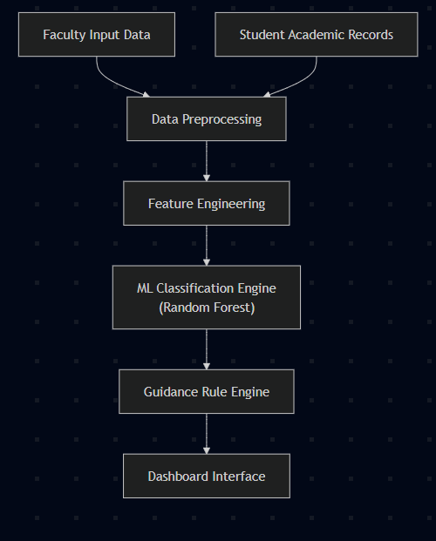
5.9 Algorithms Used and Justification
5.9.1 Algorithms Overview
Algorithm / Technique | Purpose
Rule-based logic | Attendance and penalty calculation
Statistical aggregation | Score computation, averages, percentiles
Random Forest Classifier | Performance classification
Percentile calculation | Batch comparison
Trend analysis | Performance history and evolution

5.9.2 Random Forest Classifier
Used to classify students into categories:
- Excellent,
- Good,
- Average,
- At Risk,
- Critical.
Why Random Forest?
- Handles multiple correlated academic features.
- Robust to noise and small variations in marks.
- Supports feature importance, which is explainable to faculty.
- Non-linear decision boundaries fit real-world academic data.
5.9.3 Rule-Based Engine
Used for:
- Attendance penalty logic (e.g., if attendance < threshold, reduce effective score).
- Internal mark reduction rules.
- Mapping performance patterns to human-readable guidance messages:
  - Example: Low attendance + moderate marks → “Improve class presence to stabilize performance.”
- Ensures transparency and interpretability.
5.10 Data Management Strategy
- Current tables store latest academic records per student per subject.
- History tables store snapshots of previous records when updates occur.
- History entries are append-only (no updates/deletes).
- All faculty actions (insert, update) are logged with:
  - User ID,
  - Timestamp,
  - Operation type.

6. System Design
6.1 Use Case Diagram
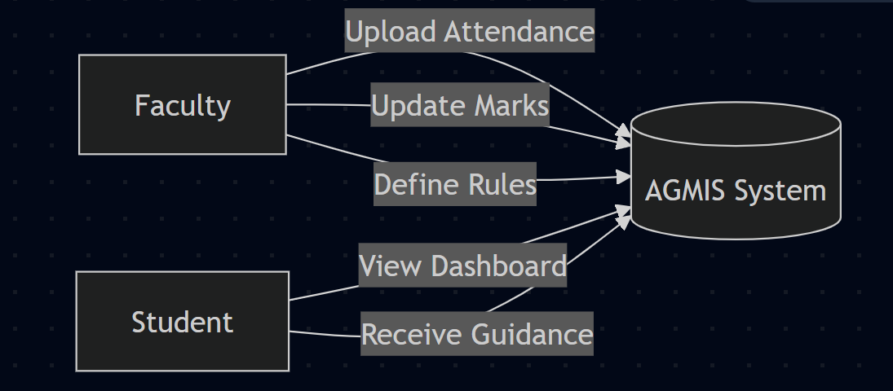Explanation:
- Faculty interact with AGMIS to feed and configure data.
- Students consume the analytics and guidance, without any write permissions.
6.2 Data Flow Diagrams (DFD)
6.2.1 DFD – Level 0 (Context Diagram)
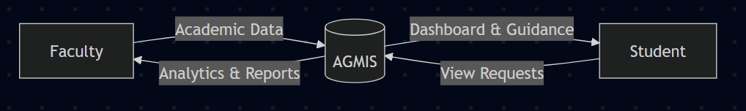6.2.2 DFD – Level 1 (Major Processes)
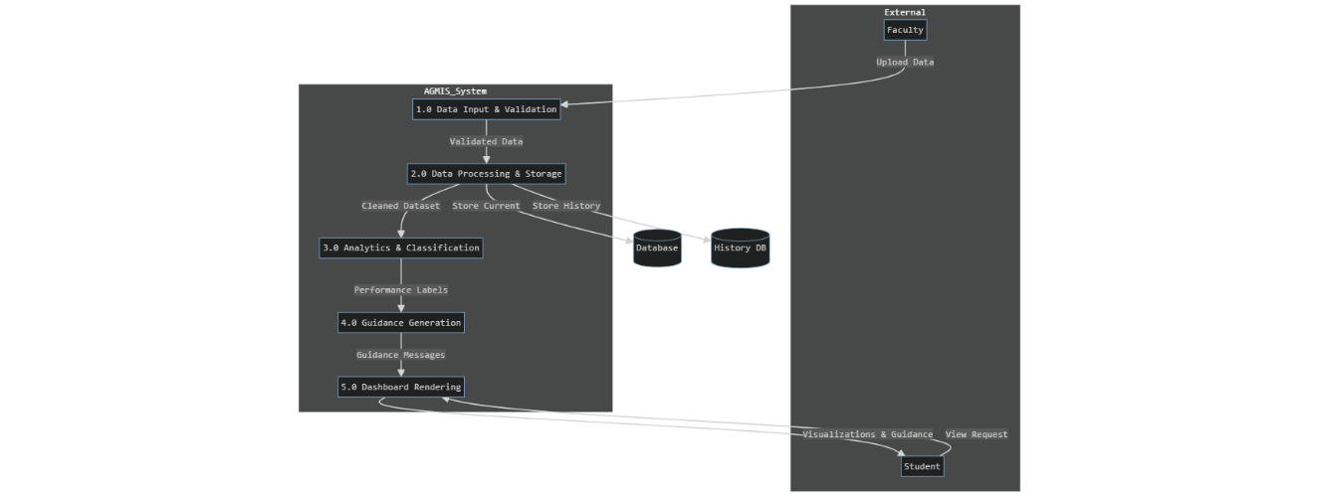
6.2.3 DFD – Level 2 (Analytics & Guidance Detail)
flowchart TD
A[Cleaned Dataset] --> B[Feature Engineering]
B --> C[Random Forest Classification]
C --> D[Performance Categories]
D --> E[Rule-Based Guidance Mapping]
E --> F[Guidance Messages + Alerts]
6.3 ER Diagram (Logical Data Model)
erDiagram
STUDENT ||--o{ ENROLLMENT : has
STUDENT {
int student_id PK
string name
string email
string batch
string department
}
SUBJECT ||--o{ ENROLLMENT : covers
SUBJECT {
int subject_id PK
string subject_name
int semester
}
ENROLLMENT ||--o{ ACADEMIC_RECORD : records
ENROLLMENT {
int enrollment_id PK
int student_id FK
int subject_id FK
}
ACADEMIC_RECORD {
int record_id PK
int enrollment_id FK
float attendance_percentage
float internal_marks
float assignment_score
float exam_score
float weighted_score
string performance_category
date record_date
}
ACADEMIC_RECORD ||--o{ ACADEMIC_HISTORY : has
ACADEMIC_HISTORY {
int history_id PK
int record_id FK
float old_attendance
float old_internal
float old_assignment
float old_exam
float old_weighted
date modified_on
}
USER ||--o{ ACTION_LOG : performs
USER {
int user_id PK
string username
string role // Admin, Faculty, Student
}
ACTION_LOG {
int log_id PK
int user_id FK
string action_type
string details
date action_time
}
6.4 Sequence Diagram
sequenceDiagram
participant Faculty
participant System
participant DB as Database
participant HDB as HistoryDB
participant ML as ML Engine
participant Student
Faculty->>System: Upload academic data
System->>DB: Store/Update current records
System->>HDB: Append previous records to history
System->>ML: Recalculate performance categories
ML-->>System: Classification results
System->>DB: Store updated categories and scores
System->>Student: Update dashboard and guidance

7. Algorithms and Models
7.1 Feature Engineering
Typical features used for classification:
- Attendance percentage per subject and overall.
- Internal assessment average.
- Assignment/practical scores.
- Mid-term / final exam scores.
- Derived metrics:
  - Weighted total score,
  - Variation between internal and external performance,
  - Improvement or decline across time (trend).
7.2 Random Forest Classifier (High-Level Pseudocode)
Input: Cleaned academic dataset with features X and target labels Y (performance category)
- Split dataset into training and testing sets (e.g., 80/20).
- Initialize RandomForestClassifier with suitable hyperparameters.
- Train the model on training data (X_train, Y_train).
- Predict on test data (X_test).
- Evaluate using classification report (precision, recall, F1, accuracy).
- Save the trained model for use in the AGMIS pipeline.
- For new data:
a. Apply same preprocessing and feature engineering.
b. Use the saved model to predict performance category.
c. Store predictions in ACADEMIC_RECORD table.
7.3 Guidance Rule Engine (Conceptual)
Examples of rules:
- If:
  - attendance < 75% AND
  - internal_marks < threshold
→ Guidance: “Your attendance and internal marks are both below expected levels. Focus on attending lectures regularly and revising internal exam topics.”
- If:
  - attendance >= 85% AND
  - exam_score low
→ Guidance: “Your attendance is good, but exam performance is weaker. Focus on exam strategies and practice with previous question papers.”
- If:
  - performance_category == "Excellent"
→ Guidance: “You are performing excellently. Maintain consistency and support peers where possible.”
This makes the system explainable: each guidance message can be traced back to a clear rule.

8. Implementation Details
- Backend Stack: Python (Pandas, Scikit-learn), FastAPI/Flask for APIs.
- Database: MySQL / PostgreSQL (relational schema as per ER diagram).
- Frontend: HTML, CSS, JavaScript; optional use of chart libraries (e.g., Chart.js) for graphs.
8.1 Modules
- Data Ingestion Module – Handles CSV/Excel upload and validation.
- Preprocessing Module – Cleans data, handles missing values, normalizes ranges.
- ML Module – Trains and applies Random Forest classifier.
- Guidance Module – Applies rule-based mapping to generate messages.
- Dashboard Module – Renders student-wise and batch-wise visualizations.

9. Testing and Validation
9.1 Types of Testing
- Unit Testing: Individual functions for preprocessing, scoring, classification.
- Integration Testing: End-to-end flow from data upload to dashboard update.
- Validation of ML Model: Using train-test split and classification report.
- User Acceptance Testing: Faculty and students test UI and feedback messages.
9.2 Evaluation of Classifier
- Metrics:
  - Accuracy,
  - Precision,
  - Recall,
  - F1-score per category.
- Confusion matrix to understand misclassifications across performance categories.

10. Results and Discussion
- The system successfully:
  - Processes academic datasets,
  - Generates performance categories,
  - Produces guidance messages,
  - Displays dashboards for different roles.
- Key observations:
  - Combining attendance and internal assessments provides more meaningful early warnings than using exam scores alone.
  - Feature importance from Random Forest helps faculty understand which factors influence classification.

11. Limitations
- Uses synthetic or limited real data for development and experimentation.
- Does not predict long-term performance (only within the current academic period).
- Batch processing is weekly, not real-time streaming.
- Assumes that uploaded data is correct and honest; garbage-in → garbage-out still applies.

12. Future Enhancements
- Integration with Learning Management Systems (LMS) for automatic data ingestion.
- Adaptive rule learning (e.g., using association rules or reinforcement signals from faculty).
- Cross-institution comparison (benchmarking between departments/colleges).
- Real-time alerts via email/SMS/app notifications when a student becomes “At Risk.”
- Advanced explainability dashboards (e.g., SHAP values for model interpretation).

13. Conclusion
The Academic Guidance and Motivation Intelligence System (AGMIS) is a practical, data-driven system that shifts academic analytics from post-mortem evaluation to early guidance. It combines:
- Structured data management,
- A justified machine learning model (Random Forest),
- A transparent rule-based guidance engine, and
- Role-based dashboards for faculty and students.
The system is technically feasible, ethically safe, and aligns with the expectations of an undergraduate data science project. It emphasizes explainability and academic relevance over black-box complexity.
Viva-Safe Line (Memorize):
“This system and its SRS define what AGMIS does and why. Every algorithm, rule, and module has been chosen for explainability and academic relevance, so that faculty can trace exactly how each guidance message was generated.”

